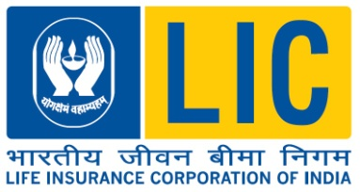
Life Insurance Corporation Of India
Jeevan Prakash,New Deoria Bypass ,Budha Vihar Commercial Scheme, Taramandal Road ,P.B. No-21 ,
Divisional Office Gorakhpur-273017
STD – 0551 TEL. NO.2230312,2230313, E-mail: sales.gorakhpur@licindia.com

NOTICE FOR EMPANELMENT OF FIRMS

Applications for empanelment are invited from reputed firms for various publicity related works under Gorakhpur divisional jurisdiction.

Cat. No. | CATEGORY
1 | Installation/ Repair/Change of Neon Sign/ LED Sign Board/ Glow Sign Boards(3M and other material with maintenance of 3 years)/ Sign Board none lit/ Mounting/ Demounting of flex, Vinyl Board, Radium Retro Plates, Tin plates/Wall Wraps etc
2 | Printing of Flex/Backdrop/Vinyl/One way vision/Standies/ Canopies/Sunboard etc.
3 | Printing of Handbills/Leaflets/Pamphlets/Brouchers/Folders/Soveniers/Bunting/Danglers etc.
4 | Mobile Van Publicity/ LED display Vans
5 | Wall Painting/Digital Wall Painting
6 | Renovation/ Branding of Park, Street, Bus shelter, Traffic Police booth or any other place
7 | Electronic LED display (Fixed)
8 | Designing and fabrication of stalls at events/fairs and Event Management etc.
The interested Firms / Suppliers / Contractors are required to collect an application form from the above address during the office hours or download the same from our website www.licindia.in (link- “tenders”) along with payment of non-refundable application cost of Rs 590/- (including GST) by demand draft in favour of Life Insurance Corporation of India payable at GORAKHPUR or by depositing cash at our cash counter during working hours.
Last Date of Submission of Application is 10.07.2024 up to 03.00 pm.

Senior Divisional Manager

