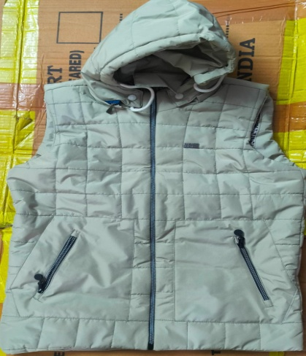
All Photos For Reference only.

Zipper Half Jacket Photo No.02
Fabric-imported Parachute
Weight: 434 gram Approx.
Hood helmet attached with jacket
02 pockets Size-15 cm
Required in all Sizes
(Will be customized as per LIC of India, D.O.Raipur)

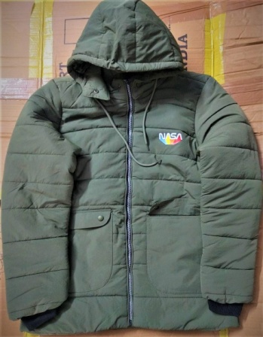
Zipper Full Jacket Photo No.03
Fabric-imported Parachute
Weight: 700 gram Approx.
Hood helmet attached with jacket
02 pockets Size-15 cm required in all sizes.
(Will be customized as per LIC of India, D.O.Raipur)

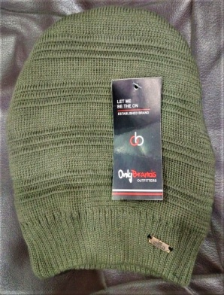
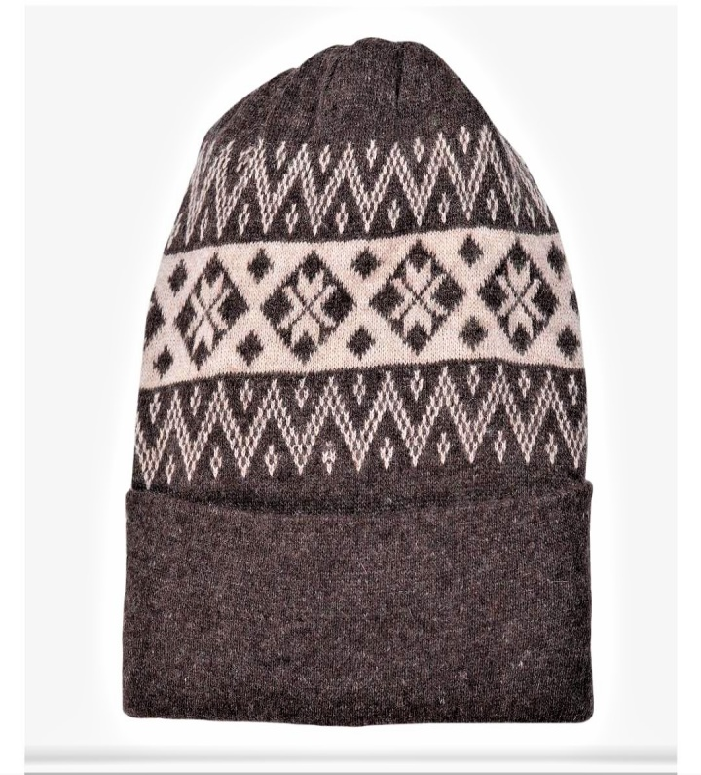
Photo No- 04 (A) Photo No. 04(B)
Fancy High Grade Woolen Caps
Required in all sizes
(Will be customized as per LIC of India, D.O.Raipur)

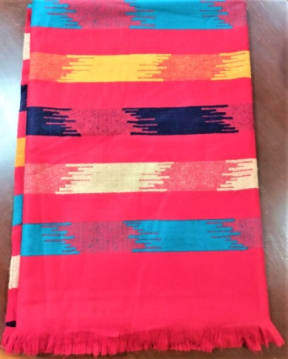
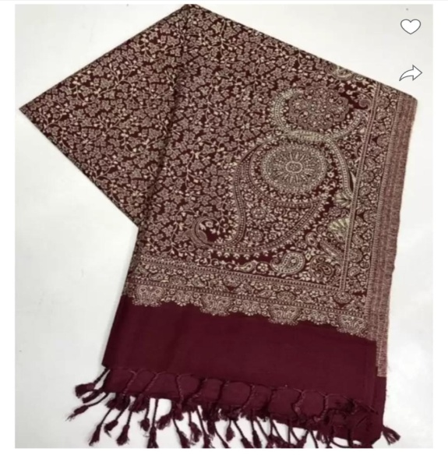
Women's Shawl (Will be customized) Women’s Shawl
Fabric - Arco wool blend Photo No. 05 (A) Photo No.05 (B)
100% softness With Digital weaving design
Length. 208 cm, Width. 94 cm
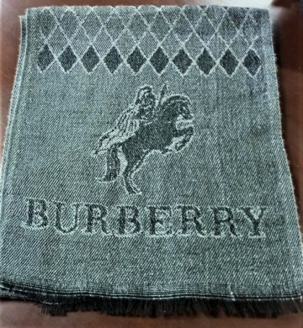 Photo- No. 06 (A) 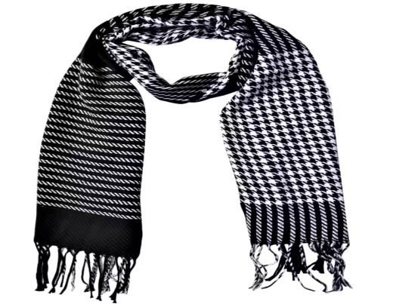
Photo No-06 (B)
Gents Muffler (Customized)
Fabric.-Traditional Wool
Width 32 cm, Length 177 cm

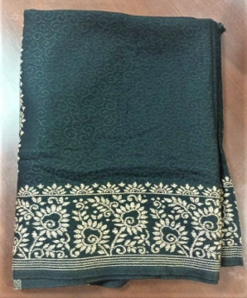

Ladies Stole (Customized) Photo No-07
Length. 208cm
Width 72 cm
Material. 100% premium soft Poly silk with traditional weaving

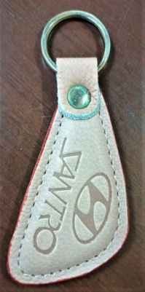
Photo No-08
Key Chain (Customized)
Material. 100 %leather
Length 10.5 cm
Width 4 cm
With customized embossed

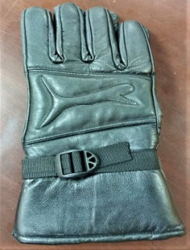
Photo No-09
Pure leather Gloves (Customized)
Material 100% leather
Size length 27 cm
Width. 13 cm

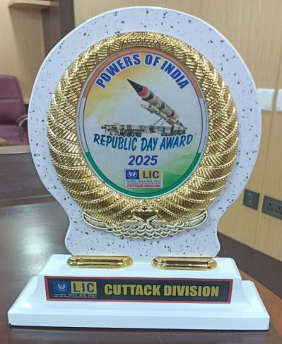
Republic Day 2025 Award (Customized)
Length. 31 cm
Width 24 cm
Upper part Material MDF
Lower Pandi ABS
Base MDF
Total weight. Approx. 800 gm
Photo No-10
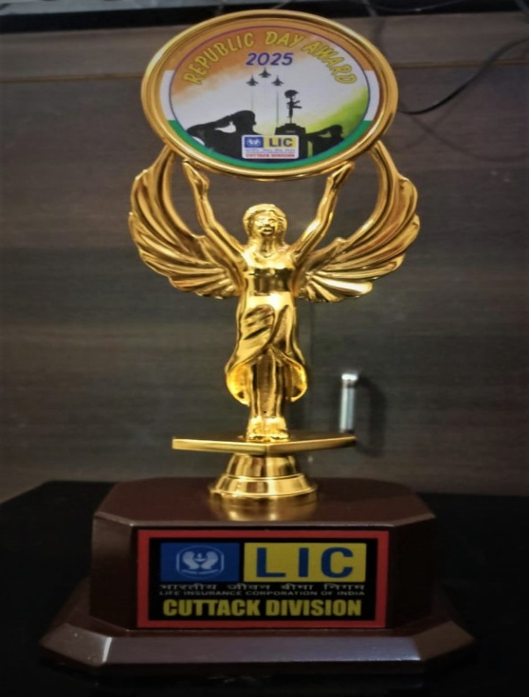
Republic Day Trophy Photo No-11
Total weight 550 gm
Upper Metal height 26 cm
Lower Pandi ABS 3.5 cm
Base height 7.5 cm
Base width 15. 5 cm
Total height 37.5

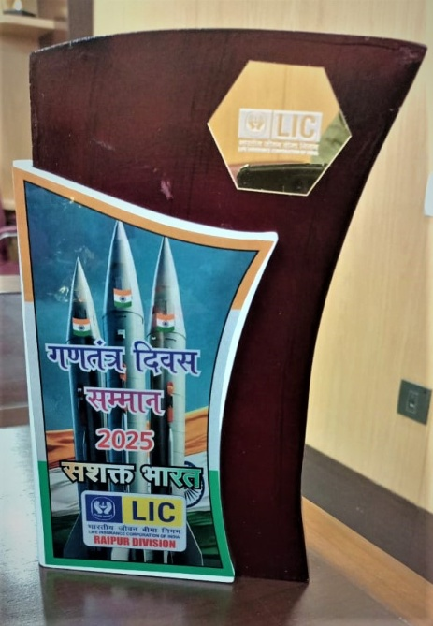
Gantantra Divas Samman Trophy
Trophy material MDF
Total weight. 500gm approx
Height 25 cm, Width. 15 cm
Material of white sheet- Fiber
Length. 19 cm, Width. 10.5 cm
With Metallic LIC logo
Photo No-12

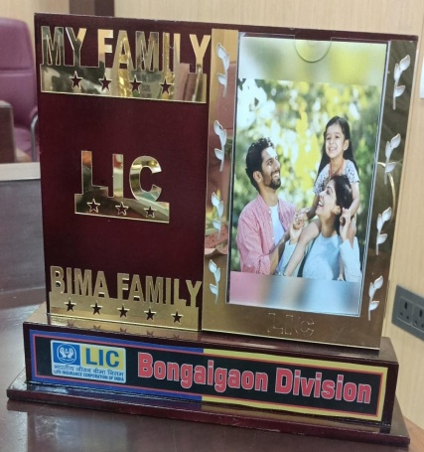
BIMA Family Photo Frame Photo No.13
Material-MDF
With customized metallic printing
Width. 32 cm, Height 22.5 cm
Wight 750 gm approx

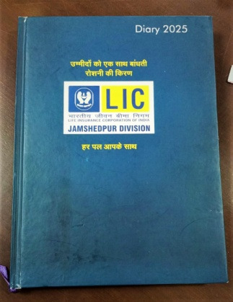

Customized Single date Diary Photo No-14
Size length. 23.5 cm
Width. 17.5
Paper-GSM. 65.
Cover-Length 24 cm, Width-18 cm

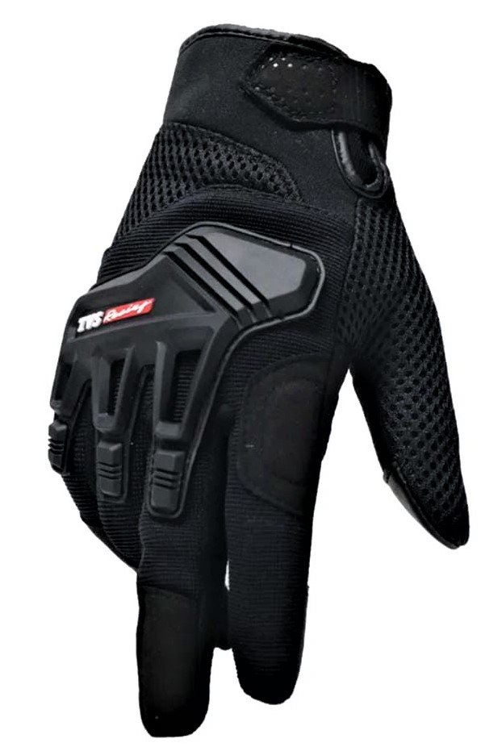
Hand Gloves
Photo No.15

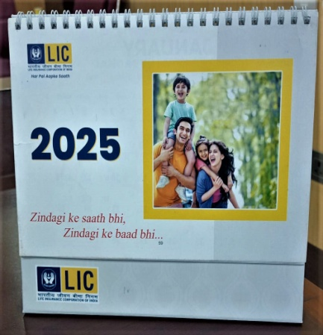

Table calendar Photo No-16
Paper 58 GSM
Spiral binding,
12 pages with both sides customized printing

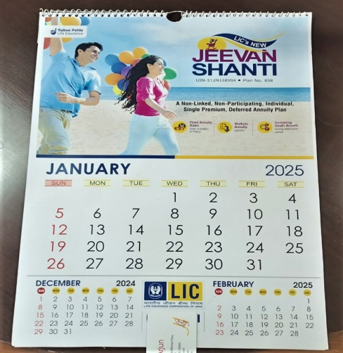
6 Pages Wall calendar Photo No.17
Paper-128 GSM
Length- 19 inch
Width-13 inch.
With spiral binding

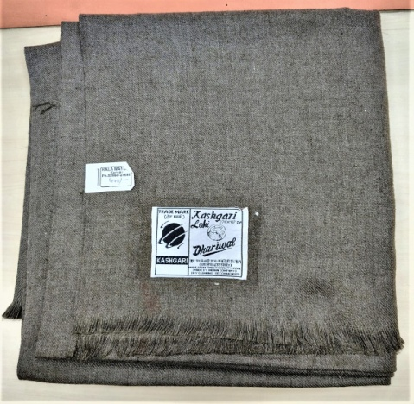
Men Shawl (Lohi)
Photo No-25 (A)

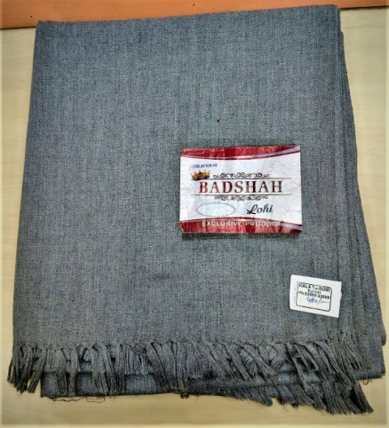
Men Shawl (Lohi) Photo No-25 (B)

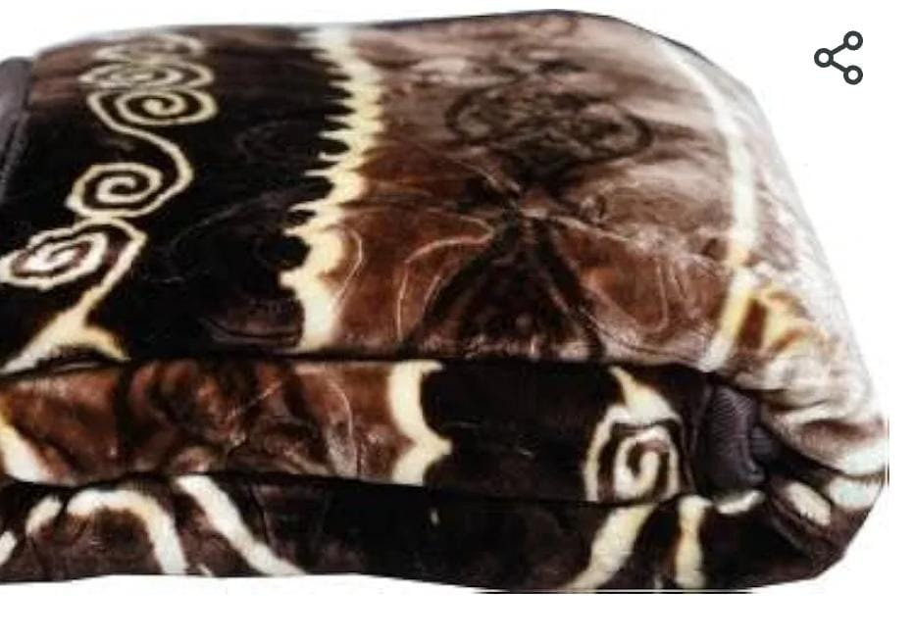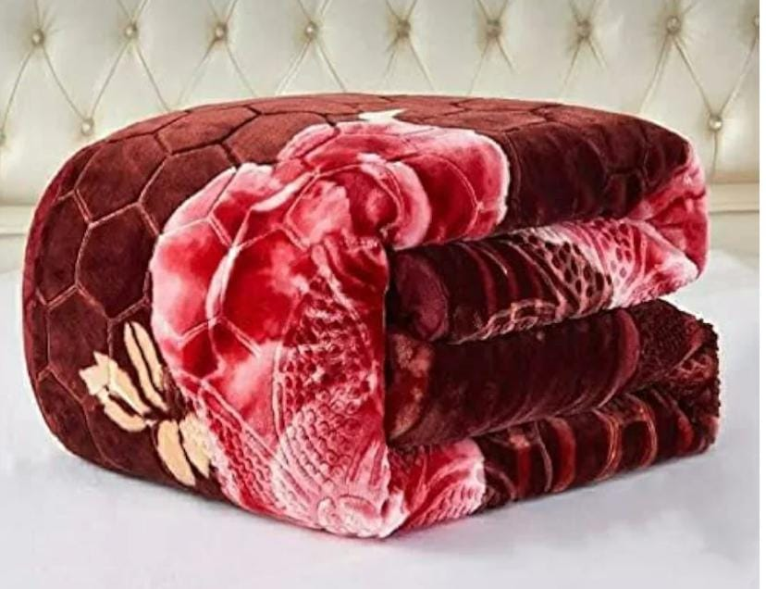
Mink Blanket Photo No- 20 (A) Mink Blanket Photo No-20 (B)
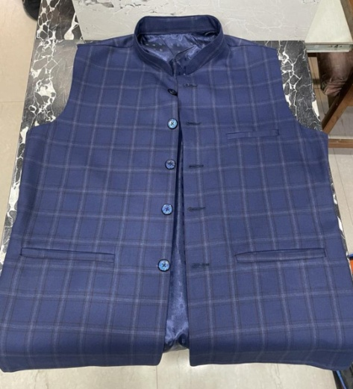
W

Waist Coat Photo No-21 (A)
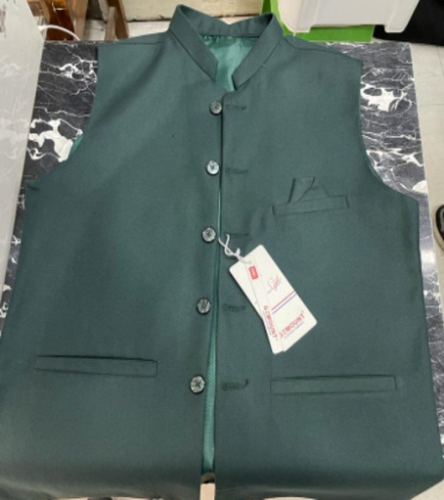
Waist Coat Photo No-21 (B)

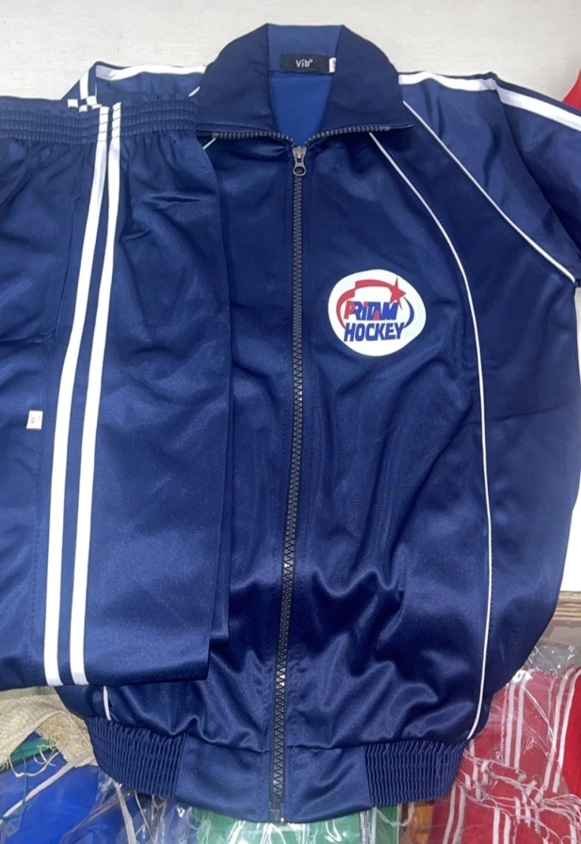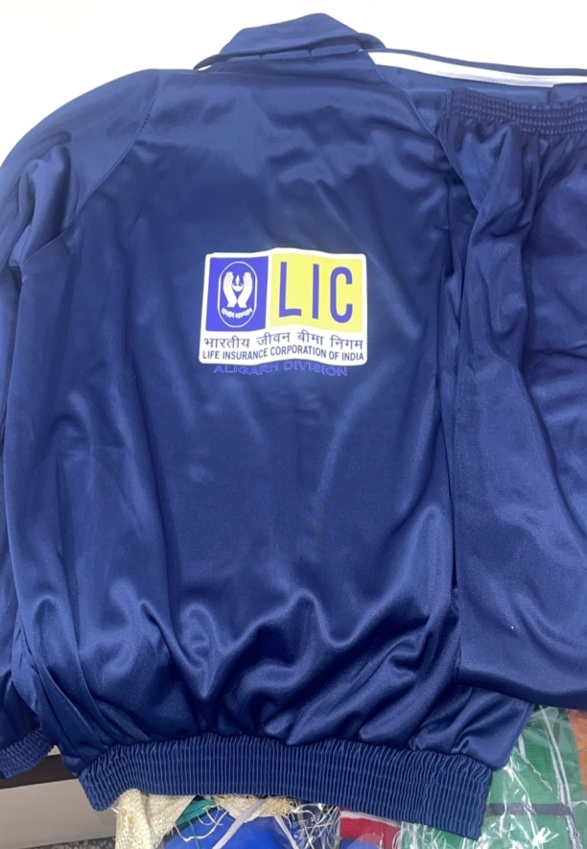
Track Suit Photo No-18

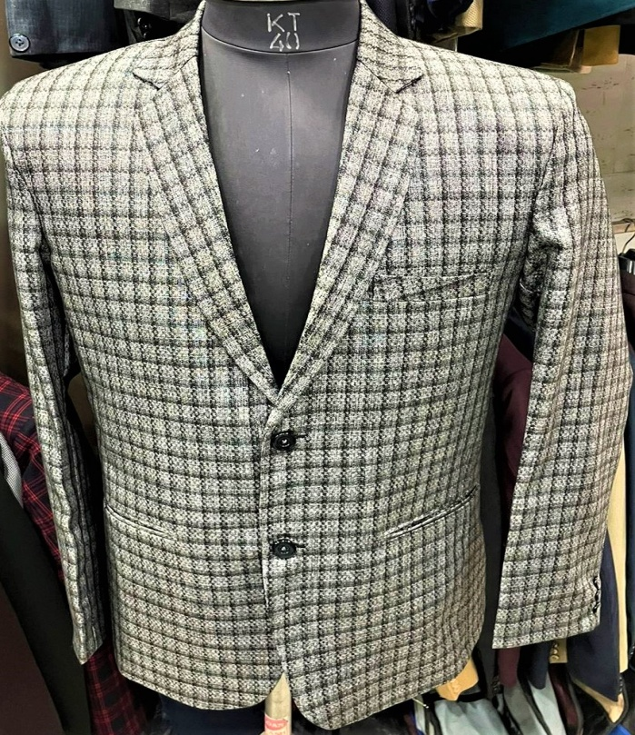
Blazer Photo No-19

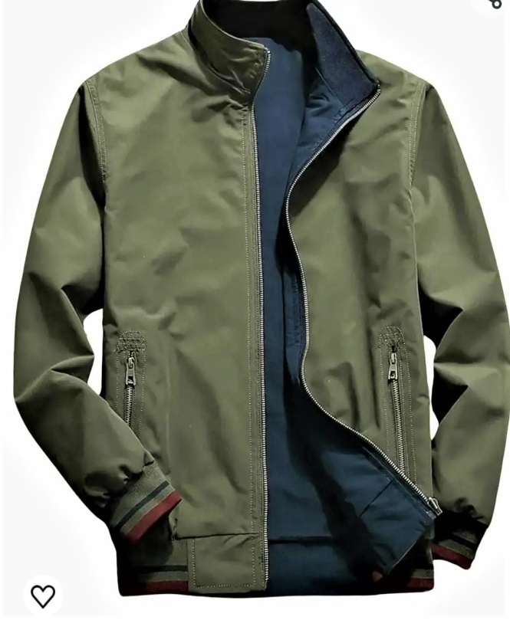
Wind Cheater Photo No- 22

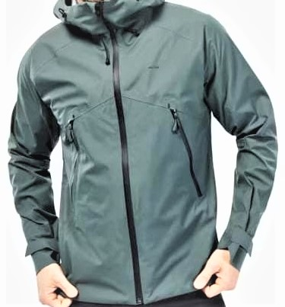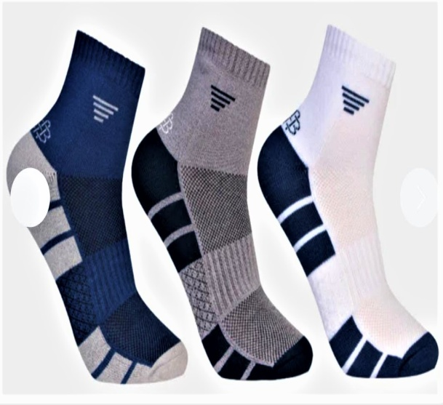
Woolen Jacket Photo No. 23 Woolen Socks Photo No.24

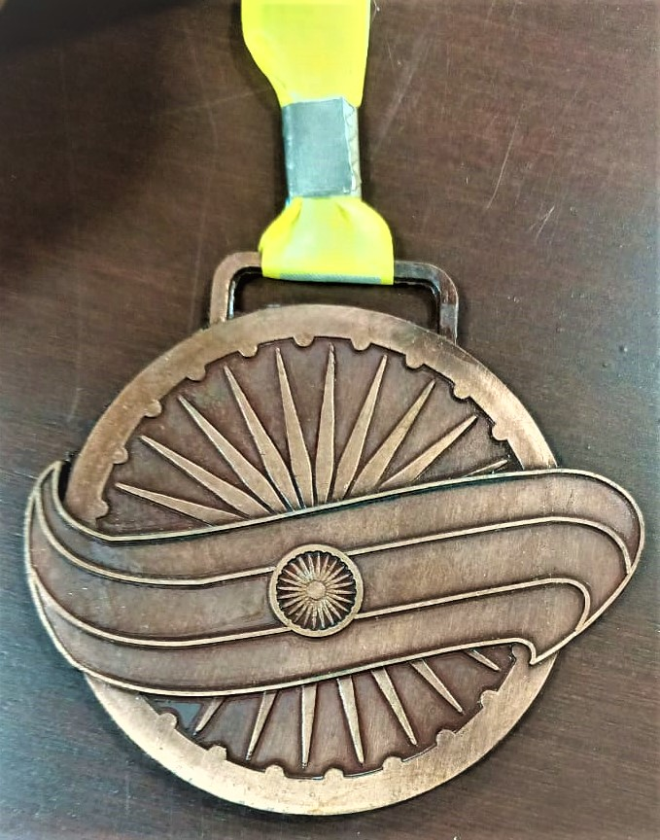
Medal
Photo No-01

