
भारतीय जीवन बीमा निगम, जबलपुर मण्डल
LIFE INSURANCE CORPORATION OF INDIA, JABALPUR DIVISION

Tender for Various Gift Articles Category-07 : Annexure: - A
PLEASE QUOTE YOUR RATE/PRICE IN FOLLOWING SLABS FOR ARTICLES

S.No | Articles Name | Articles Picture | Specification | QUANTITY | Rate
01 | Helmet (Steel bird) | 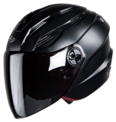 | Inner Material: Expanded Polystyrene  Size: L, Dimension: 32.5x25x24 cm,  Material: High Impact ABS Shell  Special Features: Ventilation, Visor | UP TO 100
 |  |  |  | 101 to 500
 |  |  |  | 501 to 1000
 |  |  |  | Above 1000
02 | Rain-Suit (Duck-back) | 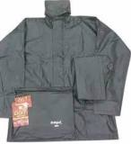 | Rain suit with hood, two pockets with flap on front | UP TO 100
 |  |  |  | 101 to 500
 |  |  |  | 501 to 1000
 |  |  |  | Above 1000
03 | Sonata-Watch  SKU-NS7987YL02W | 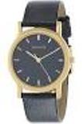 | White/Black Dial  Leather Strap Watch for Men | UP TO 100
 |  |  |  | 101 to 500
 |  |  |  | 501 to 1000
 |  |  |  | Above 1000
(ALL RATES ARE EXCULISIVE GST)

Vender Signature with seal

