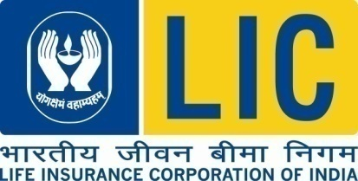

|  |
| --- |
| **PRESS RELEASE** |

|  |
| --- |
| **14.02.2025 – PANINDIA** |

**LIC of India launches Marketing Tech platform to power next-generation customer engagement under Project DIVE**

Life Insurance Corporation of India (LIC), India's largest insurer, has launched its cutting-edge Marketing Technology (MarTech) platform, marking the first major milestone in Project DIVE-LIC’s ambitious, digital transformation initiative. This launch represents LIC’s first step towards becoming a global digital champion in the insurance industry, leveraging world-class technology to revolutionize customer engagement at an unprecedented scale.

**Shri Siddhartha Mohanty, CEO & MD, LIC of India, remarked:**

"With the launch of the MarTech platform, LIC has taken the first leap on its bold new journey of digital transformation, one that will redefine customer engagement in the insurance sector. This initiative strengthens our ability to connect with policyholders, prospects and agents in a seamless and personalized manner. MarTech is more than just a technology upgrade—it is a strategic shift that positions LIC as a global leader in digital insurance innovation. Project DIVE is a testament to our vision for the future, and we remain committed to setting new industry benchmarks.”

**A Game-Changer for LIC’s Customer Engagement**

The MarTech platform introduces an intelligent, multi-channel engagement capability, enabling LIC to run hyper-personalized, always-on campaigns that enhance customer experience and drive business growth. With the first pillar under Project DIVE now live, LIC reinforces its commitment to innovation, customer centricity, and digital excellence. As Project DIVE progresses, LIC will continue to introduce next-generation digital capabilities, ensuring it remains at the forefront of the global insurance landscape.

Dated at Mumbai on February 14th, 2025

For Further Information please contact: Executive Director (CC), LIC of India, Central Office, Mumbai. Email id: ed_cc@licindia.com Visit us at www.licindia.in

**____________________________________________________________________________**

We believe that the news contained in this release is of value to your readers. While we would thank you to publish it as soon as possible, we also readily recognize that the decision to do so rests entirely with you.